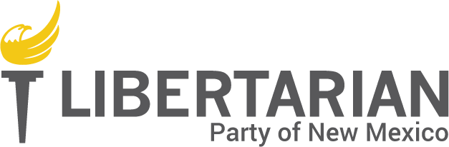

8100 Wyoming Blvd NE, Ste M4, #341
Albuquerque NM 87113

505-225-1119 | 575-680-3122 | 888-LPNM-NOW

lpnm.us

VOLUNTEER QUESTIONNAIRE

NAME: _______________________________________________________________________________

ADDRESS: _____________________________________________________________________________

PHONE: _________________________ E-MAIL: ______________________________________________

Best way to contact me: _________________________________

Are you under 18 years of age? ___ Yes ___ No

Person to contact in case of emergency:

Name: ___________________________________ Cell phone: ________________________________

Relationship: _____________________________ Alternate phone (optional): ___________________

Why do you wish to volunteer with the LPNM? What cause are you the most passionate about?

_____________________________________________________________________________________

_____________________________________________________________________________________

Do you have previous political or activist experience? Tell us about it: ____________________________

_____________________________________________________________________________________

What types of projects do you prefer to work on? (Check all that apply)

____ Ongoing, i.e.: 2-4 hours weekly/monthly ____ One-time (special events)

____ Long-term, i.e.: several weeks ____ Short-term projects, i.e.: a few hours

Are there types of projects you’d like to avoid? ____ No.

Yes: ___________________________________________________________________________________

I prefer to volunteer at these times (check all that apply):

____ Weekdays, daytime

____ Weekdays, evenings

____ Saturdays

____ Sundays

VOLUNTEER SKILLS & INTERESTS INVENTORY

My skills include:

____ General clerical | ____ Human resources
____ Technical web management/Word Press | ____ Advertising/marketing/public relations
____ Graphic design | ____ Database management
____ Administration/management | ____ Political theory/campaigning
____ Legal | ____ Photography/Video/Multimedia

Other special skills: ____________________________________________________________________

Given adequate training, I am willing to (check all that apply):

____ Wear an LPNM t-shirt at a rally | ____ Wave campaign signs on a busy street corner
____ Speak at a city/county council meeting | ____ Contribute to the LPNM’s social media sites
____ Work the State Fair booth for 4 hours | ____ Write a story for the newsletter
____ Walk my neighborhood to put brochures on doors | ____ Take photos or video at LPNM events
____ Hold a local LPNM event regularly | ____ Organize a campus event
____ Contact new members by phone to welcome them to the LPNM | ____ Respond to new member/volunteer emails
____ Make informational phone calls to promote the LPNM | ____ Provide graphic design services for the newsletter, brochures and other needs
____ Make fundraising phone calls on behalf of the LPNM | ____ Send promotional or fundraising text messages to people who have opted in
____ Participate on a special events committee, such as organizing the annual convention | ____ Serve on a committee to develop administrative procedures and policies
____ Supervise other volunteers | ____ Provide WordPress support
____ Maintain master calendars of events and tasks | ____ Print letters at home & stuff envelopes
____ Work a phone bank for 2 hours | ____ Do data entry
____ Create & maintain a database | ____ Serve on a county executive committee
____ Travel to an event in another part of the state | ____ Serve as a poll official on election day
____ Be listed in the LPNM Speakers Bureau | ____ Deliver a presentation to local schoolchildren

Is there something you’d like to do that we forgot to list? Tell us! ____________________________________

_________________________________________________________________________________________

_________________________________________________________________________________________

I certify that the statements made in this volunteer application are true and correct, have been given voluntarily, and understand that misrepresentation is just cause for dismissal. My services are donated to the Libertarian Party of New Mexico without contemplation of compensation or future employment and given
with charitable reasons. I understand that failure to follow LPNM policies and procedures may be grounds for
dismissal.

Applicant’s signature:______________________________________ Date:____________________

Opportunities for volunteers are provided without regard to religion, creed, race, national origin,
age, gender, sexual orientation/identity, or disability.

Complete this questionnaire, sign, and return it to the LPNM either by snail mail to the address listed at top or scanned and emailed to members@lpnm.us

