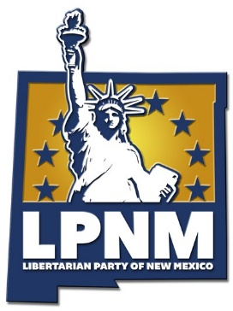

LIBERTARIAN PARTY OF NEW MEXICO
CENTRAL COMMITTEE MEETING
AGENDA FOR SEPTEMBER 15th, 2018

I. 3:50 p.m. - 4:00 p.m.
Check in.
II. 4:00 p.m. -4:10 p.m.
Call to Order: Welcome by Vice-Chair Helen Milenski and a Brief LPNM Update since the June 16th 2018 Central Committee Meeting and Reminder that Robert’s Rules are in effect.
III. 4:10 p.m. - 4:12 p.m.
Review and Approval of the June 16, 2018 Central Committee Meeting Minutes.
IV. 4:12 p.m. - 4:15 p.m.
Rebecca Lescombes - Treasurer’s Report.
V. 4:15 p.m. - 4:35 p.m.
Committee Reports
(1) 4:15 p.m. - 4:25 p.m. - Finance, Fundraising, and Administrative Committee Report by Committee Chair Paul Ryan McKenney and Opportunity for Motions/Discussion on funding requests.
(2) 4:25 p.m. - 4:30 p.m. - Membership, Outreach, and Technology Committee Report by Committee Chair Ginger Grider and Opportunity for Motions/Discussion.
(3) 4:30 p.m. - 4:35 p.m. - Politics, Policy, Constitution and Bylaws Committee Report by Committee Chair Jay Vandersloot and Opportunity for Motions/Discussion.

VII. 4:35 p.m. - 4:45 p.m.
Special Orders.
- State Convention 2019 Date
- Paul Ryan McKenney Presentation on the 2019 LPNM State Convention

VIII. 4:45 p.m. - 5:30 p.m.
New Business.

4:45 p.m. - 5:00 p.m. Contract with Don Bruckner for 10 hours of any urgent legal work that may arise.
5:15 p.m. - 5:30 p.m. Request by Ranota Banks for volunteers for upcoming events throughout the state.
5:30 p.m. – 5:45 p.m. Updates from County Affiliate Chairs.
5:45 p.m. – 6:00 p.m. Progress Reports by NM Libertarian Candidates

IX. 6:00 p.m.
Adjournment.

